https://doi.org/10.5755/j02.eie
Preparation of Papers for Elektronika ir Elektrotechnika

First A. Author^{1,2}, Second B. Author¹, Third C. Author^{2,*} ←Abbreviations aren’t allowed
¹Department of Electronics Engineering, Kaunas University of Technology,
Studentu St. 50–438, LT-51368 Kaunas, Lithuania
²Institute of Automation and Control Technologies, Kaunas University of Technology,
Studentu St. 48, LT-51367 Kaunas, Lithuania
first.author@mailserver.com; second.author@mailserver.com;
corresponding.third.author@mailserver.com*

Abstract—These instructions give you guidelines for preparing papers for Elektronika ir Elektrotechnika. Use this document as a template if you are using Microsoft Word. Otherwise, use this document as an instruction set. Abstract, with a maximum of 1300 characters (with spaces), should be self-explanatory and summarize the essential qualities of the paper. The abstract must clearly state the novelty of the work regarding the journal fields. Do not use other characters, like special symbols, Greek alphabet letters, subscript and superscript styles in the abstract. Do not cite references in the abstract. Do not delete the blank line immediately above the abstract; it sets the footnote at the bottom of this column. Avoid abbreviations and acronyms in the abstract unless they are commonly understood and used multiple times in the abstract. If an abbreviation or acronym is used in the abstract, it must be spelled out, except the cases mentioned in Section XI. HELPFUL HINTS (A. Abbreviations and Acronyms).

Index Terms—About four key words or phrases in alphabetical order, separated by semicolons. A list of key words may be found on the web-site https://www.ieee.org/content/dam/ieee-org/ieee/web/org/pubs/ieee-taxonomy.pdf . Try to use only the key words defined there.

Introduction
The journal ELEKTRONIKA IR ELEKTROTECHNIKA is an open-access journal and is licensed under the Creative Commons Attribution 4.0 (CC BY 4.0) licence. It publishes previously unpublished manuscripts that will have a high impact in the field of electronics and electrical engineering. The journal targets not only certain field specialists, but the wider public also.
Papers should be written in English and submitted in final camera-ready form. The paper should be prepared using Microsoft Word (*.doc, *.docx) and submitted using our on-line manuscript submission system http://eejournal.ktu.lt. All text has to be edited by using the styles defined in this document.
The length of the manuscript should be 6–12 pages. If your paper is longer than 12 pages (13 and more), please contact us before uploading it in the interface. At least 75% of the last page should be occupied by text.

Manuscript received XX October, 20XX; accepted XX April, 20XX.
This research was supported by the <Funding Agency #1> under Grant No. [number xxxx]; <Funding Agency #2> under Grant No. [number xxxx]; and <Funding Agency #3> under Grant No. [number xxxx].
All subsequent versions should be uploaded by using the same paper ID and your defined user name and password. We are unable to process files sent by E-mail.

Author(s) Guarantee Form
The author(s) guarantee form has to accompany each submission. You can get the PDF form version on-line.
Authors are responsible for obtaining any security clearances.
All authors are required to sign the form. The signed copyright form has to be scanned and uploaded on the web-site.

Ethics
Originality of the submitted manuscript is the authors responsibility. Authors must avoid duplicate submission, plagiarism, and self-plagiarism. Manuscript submission will be looked-over against plagiarism at the CrossCheck database (http://www.ithenticate.com/). iThenticate is a service that verifies the originality of content submitted, and helps to identify plagiarism. Authors can also use iThenticate service to screen before submission on their own credentials.

Permissions
Authors wishing to include figures, tables, or text passages that have already been published elsewhere are required to obtain permission from the copyright owner(s) for both the print and online format and to include evidence that such permission has been granted when submitting their papers. Any material received without such evidence will be assumed to originate from the authors.

Copyright
Authors retain copyright and grant the journal the right of the first publication with the paper simultaneously licensed under the Creative Commons Attribution 4.0 (CC BY 4.0) licence that allows others to share the work with an acknowledgement of the authorship of the work and initial publication in the journal.
Authors are allowed to enter into separate, additional contractual arrangements for the non-exclusive distribution of the paper published in the journal (e.c., post the paper to an institutional repository or publish the paper in a book), with an acknowledgement of the initial publication in the journal.

Co-Authorship
Author name, affiliation and complete address are to be placed underneath the title. In case of multiple authorship of a submitted paper, the affiliation and complete addresses of each co-author must be specified. If there is more than one author, please clearly indicate with an asterisk (*) who will handle the correspondence at all stages of refereeing and publication, also post-publication. Any change to the author names listed in the original manuscript, including additions, deletions, and/or a change in order of appearance, requires proof of agreement of all co-authors. Once paper is accepted, further change of co-authors is prohibited.

Paper and Text Format
This document is a template for Microsoft Word. If you are reading a paper or PDF version of this document, please download the electronic file from the journal Web site http://eejournal.ktu.lt so you can use it to prepare your manuscript.
When you open this document, select “Page Layout” from the “View” menu in the menu bar (View | Page Layout), which allows you to see the footnotes. Then type over sections or cut and paste from another document and then use markup styles. The pull-down style menu is at the left of the Formatting Toolbar at the top of your Word window (for example, the style at this point in the document is “Text”). Highlight a section that you want to designate with a certain style, and then select the appropriate name on the style menu. The style will adjust your fonts and line spacing. Do not change the font sizes or line spacing to squeeze more text into a limited number of pages. Use italics for emphasis; do not underline.
To insert images in Word, position the cursor at the insertion point and either use Insert | Picture | From File or copy the image to the Windows clipboard and then Edit | Paste Special | Picture (with “Float over text” unchecked).
TABLE I. The Recommended Fonts.
Item | Font | Size | Style
Title of paper | Times New Roman | 24 pt | Normal
Authors' names | Times New Roman | 11 pt | Bold
Authors' address | Times New Roman | 11 pt | Italic
Abstract | Times New Roman | 9 pt | Bold
Title of sections | Times New Roman | 10 pt | Normal
Text, Formulae | Times New Roman | 10 pt | Normal
Algorithms | Courier New | 10 pt | Normal
References | Times New Roman | 8 pt | Normal

Tables, Figures
Illustrations should be numbered consecutively in Arabic numerals, while tables in Roman numerals, following the order cited in the text; they may be organized in one or two columns. Tables must be accompanied by a caption placed at the top ("Table Title" style). Figures (abbreviated Fig. X in the caption and Fig. X in the text) must be accompanied by a caption placed underneath ("Figure Caption" style). References made to tables in text will not be abbreviated e.g. “in Table I”. If your figure has two parts or more, include the labels “(a)” and “(b)”, etc. as separate text after each part. Do not use automatic citation function for citing tables, and figures.
Figure axis labels are often a source of confusion. Use words rather than symbols. As an example, write the quantity “Magnetization,” or “Magnetization M,” not just “M.” Put units in parentheses. Do not label axes only with units. Do not label axes with a ratio of quantities and units. For example, write “Temperature (K),” not “Temperature/K.” Figure labels should be legible, approximately 8 to 11-point type.
Make sure the axis labels and other items are part of the artwork. Do not use text boxes for labeling the pictures or figure captions.
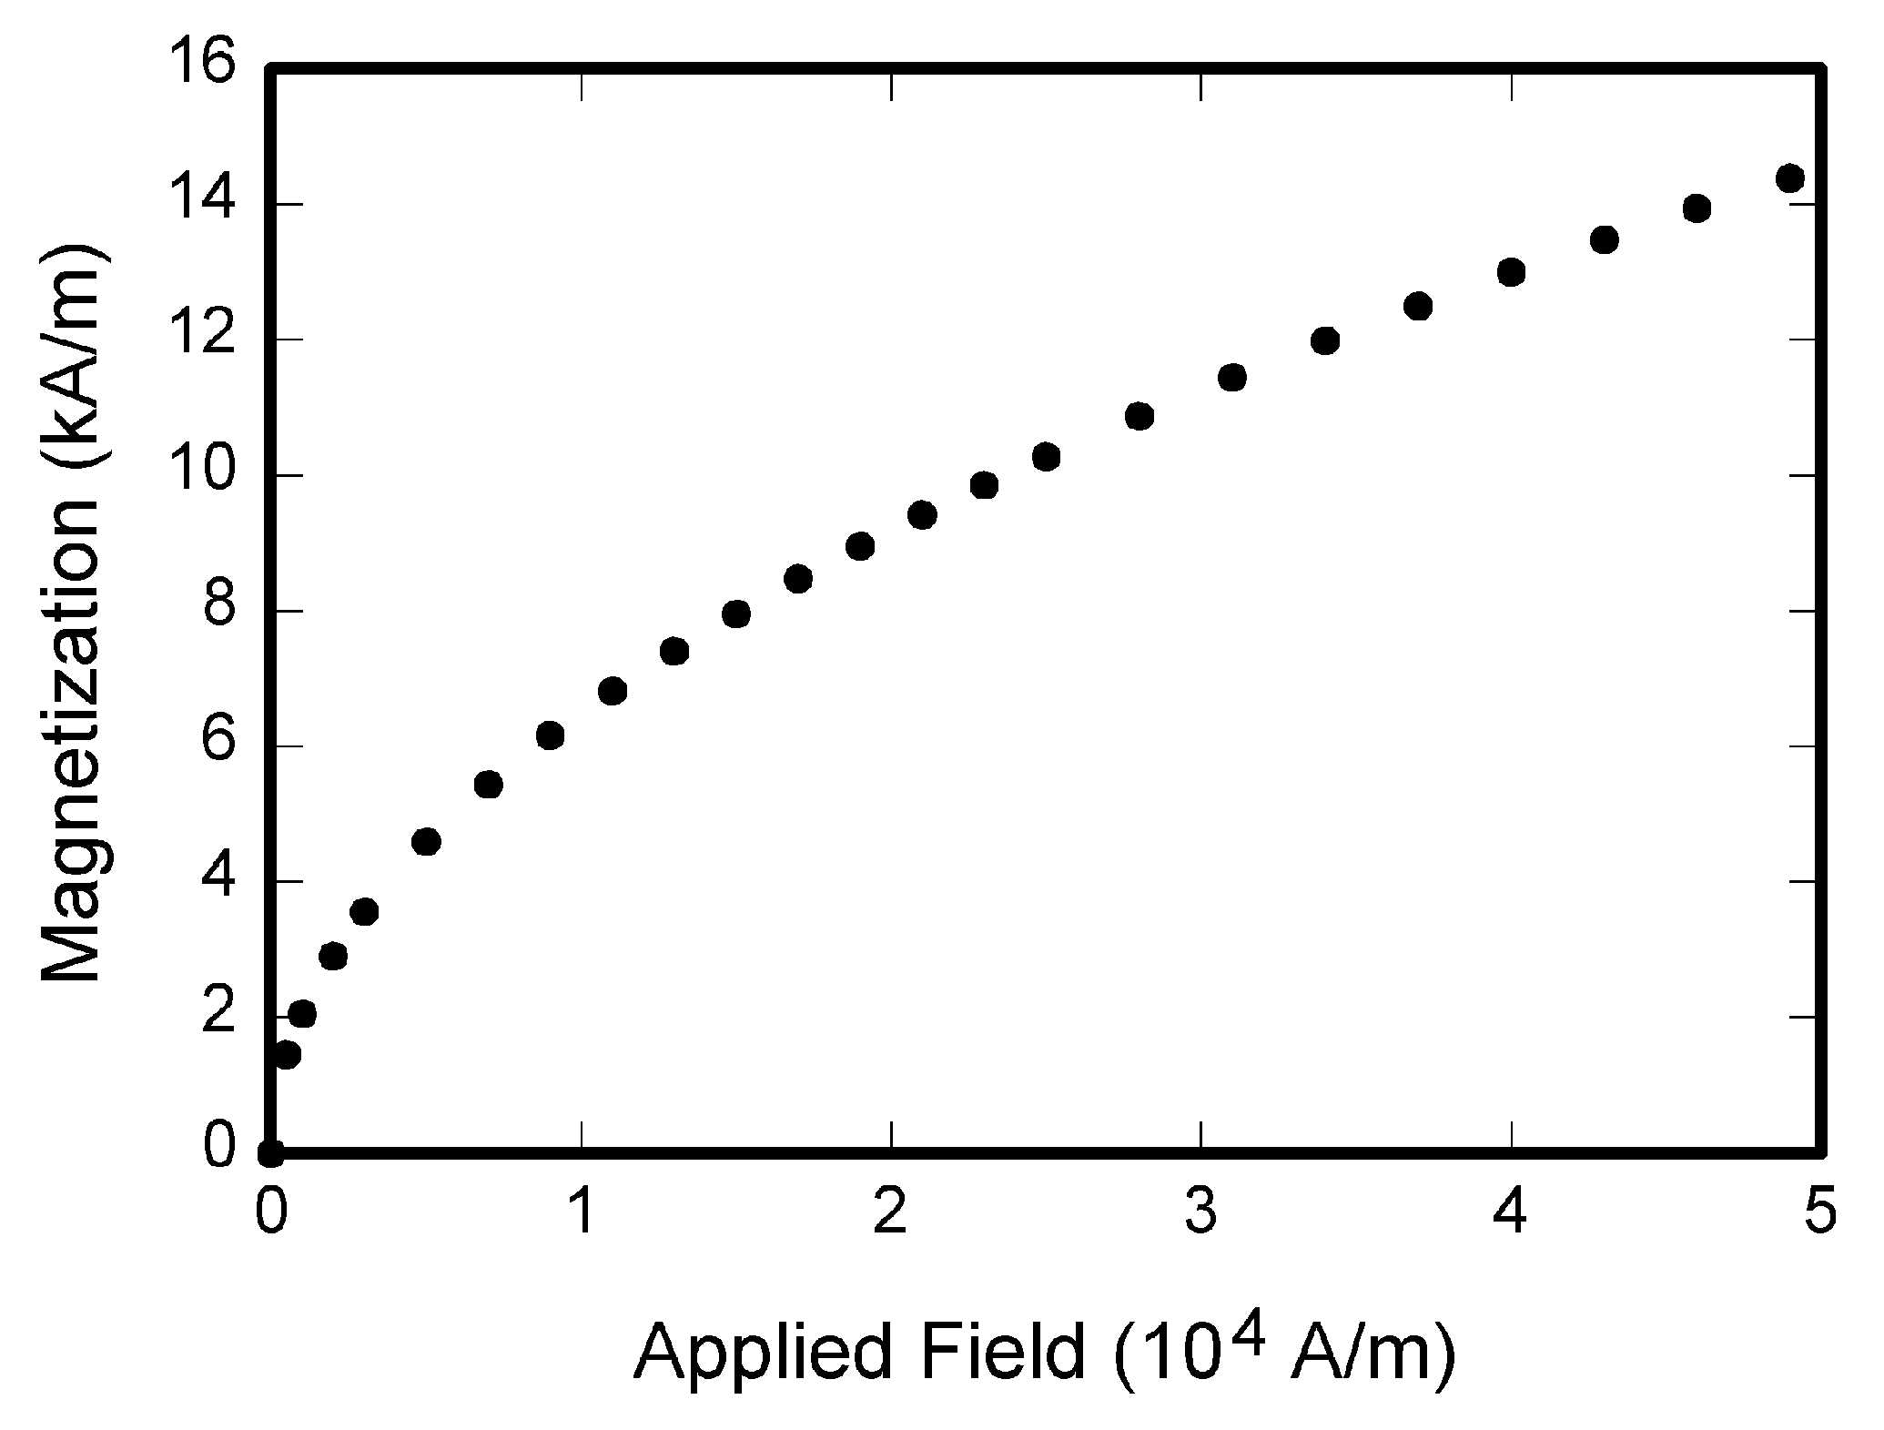
Fig. 1. Magnetization as a function of applied field. Note that “Fig.” is abbreviated. There is a period after the figure number, followed by two spaces. It is good practice to explain the significance of the figure in the caption.
Please verify that the figures and tables you mention in the text actually exist.
If you are importing your graphics into this Word template, please use the following steps:
Under the option EDIT select PASTE SPECIAL. A dialog box will open, select paste picture, then click OK. Your figure should now be in the Word Document.

Electronic Image Files
Format and save your graphic images using a suitable graphics processing program that will allow you to create the images Encapsulated PostScript (EPS) or Tagged Image File Format (TIFF), sizes them, and adjusts the resolution settings. If you created your source files in one of the above-mentioned formats, you will be able to submit the graphics without converting them to an EPS or TIFF file. Image quality is very important to how yours graphics will reproduce. Even though we can accept graphics in many formats, we will not be able to improve your graphics if they are poor quality when we receive them. If your graphic looks low in quality on your printer or monitor, please keep in mind you will have no possibility to improve its quality after the submission.
Figures should be prepared with 600 dpi resolution and saved with no compression, with file names in the form of “fig3.tif”.
Aspect ratio should be left untouched.
If a graphic is to appear in print or on-line in colour, it should be submitted as RGB colour. Please note that the journal publishes colour figures in on-line version and black and white figures in print. All figures should be understandable without colour.
Colour printing of figures in print is available, but is billed to the authors. Include a note with your final paper indicating that you request and will pay for the colour printing.
The compressed graphic files (*.zip, *.rar) have to be uploaded on the web-site.

Equations
The equations should be prepared using “Microsoft Equation 3.0” or “MathType” editor, and appear in a text as a separate object. (Insert | Object | Create New | Microsoft Equation 3.0 or MathType Equation). “Float over text” should not be selected. The equations may also be prepared using built-in “Microsoft Equation” editor.
Each formula should occupy one line. The equation should be in the centre of the column. Equations should be numbered consecutively with Arabic numerals and cited (1) in the text. Do not place several equations under one number. Do not use automatic citation function for citing equations. Consecutive numbers should be marked in parentheses flush with the right margin, as in (1). First use the equation editor to create the equation. Then select the “Equation” markup style. Press the tab key before and after equation, and write the equation number in parentheses. To make your equations more compact, you may use the solidus ( / ), the exp function, or appropriate exponents. Use parentheses to avoid ambiguities in denominators. Punctuate equations when they are part of a sentence, as in
(1)
Be sure that the symbols in your equation have been defined before the equation appears or immediately following. Italicize symbols (T might refer to temperature, but T is the unit tesla). Refer to “(1),” not “Eq. (1)” or “equation (1),” except at the beginning of a sentence: “Equation (1) is ...”.
TABLE II. Requirements for the Equations.
Elements of the formulas | Font size | Font style | Type
Text | 10 pt | Normal | Times New Roman
Functions | 10 pt | Normal | Times New Roman
Variables | 10 pt | Normal | Symbol, Italic
L.C.Greek | 8 pt | Normal | Symbol, Italic
U.C.Greek | 10 pt | Normal | Symbol, Italic
Symbols | 12 pt | - | Symbol
Subsymbols | 10 pt | - | Symbol
Vectors and matrices | 10 pt | Bold | Times New Roman
Subscript/Superscript | 8 pt | Normal
Sub- Subscript/Superscript | 7 pt | Normal

Helpful Hints

Abbreviations and Acronyms
Do not use abbreviations in the title unless they are unavoidable. Avoid abbreviations and acronyms in the abstract unless they are commonly understood and used multiple times in the abstract. If an abbreviation or acronym is used in the abstract, it must be spelled out (defined) in the abstract, and then spelled out again the first time it is used in the main text of the paper. Abbreviations such as AC, and DC do not have to be defined. Abbreviations that incorporate periods should not have spaces: write “C.N.R.S.,” not “C. N. R. S.”.

Other Recommendations
Use one space after periods and colons. Hyphenate complex modifiers: “zero-field-cooled magnetization”. Avoid dangling participles, such as, “Using (1), the potential was calculated”. [It is not clear who or what used (1)]. Write instead, “The potential was calculated by using (1)”, or “Using (1), we calculated the potential”.
Use a zero before decimal points: “0.25”, not “.25”. Use “cm³”, not “cc”. Indicate sample dimensions as “0.1 cm × 0.2 cm”, not “0.1 × 0.2 cm²” The abbreviation for “seconds” is “s”, not “sec”. Do not mix complete spellings and abbreviations of units: use “Wb/m²” or “webers per square meter”, not “webers/m²”. When expressing a range of values, write “7 to 9” or “7–9”, not “7~9”.
Remember to check spelling. If your native language is not English, please get a native English-speaking colleague to carefully proofread your paper. Try to avoid repetitions; Keep the text short and simple; Take care to use the proper tenses when describing your work and findings; Avoid shifting tenses within a unit of text: paragraph, sub-section or section; Introduce abbreviations and acronyms systematically the first time they are used in a document.

Some Common Mistakes
The word “data” is plural, not singular. The subscript for the permeability of vacuum µ₀ is zero, not a lowercase letter “o”. Use the word “micrometer” instead of “micron”. A graph within a graph is an “inset,” not an “insert.” The word “alternatively” is preferred to the word “alternately” (unless you really mean something that alternates). Use the word “whereas” instead of “while” (unless you are referring to simultaneous events). Do not use the word “essentially” to mean “approximately” or “effectively”. Be aware of the different meanings of the homophones “affect” (usually a verb) and “effect” (usually a noun), “complement” and “compliment,” “discreet” and “discrete”, “principal” (e.g., “principal investigator”) and “principle” (e.g., “principle of measurement”). Do not confuse “imply” and “infer.”
Prefixes such as “non”, “sub”, “micro”, “multi”, and “ultra” are not independent words; they should be joined to the words they modify, usually without a hyphen. There is no period after the “et” in the Latin abbreviation “et al.” (it is also italicized). The abbreviation “i.e.,” means “that is,” and the abbreviation “e.g.,” means “for example” (these abbreviations are not italicized).

References Section
Number the citations consecutively, in square brackets [1]. The sentence punctuation follows the brackets [2]. Multiple references [2], [3] are each numbered with separate brackets [1]–[3]. When citing a section in a book, please give the relevant page numbers [2]. You should avoid citing theses, dissertations or books. In sentences, refer simply to the reference number, as in [3]. Do not use “Ref. [3]” or “reference [3]” except at the beginning of a sentence: “Reference [3] shows ....” Please do not use automatic endnotes in Word, rather, type the reference list at the end of the paper using the “References” style. Do not use automatic citation function for citing references.
Please note that the references at the end of this document are in the preferred referencing style. Give all authors’ names; do not use “et al.” unless there are six authors or more. Use a space after authors’ initials. Papers that have not been published should be cited as “unpublished” [5]. Papers that have been accepted for publication, but not yet specified for an issue should be cited as “to be published” [6]. Papers that have been submitted for publication should be cited as “submitted for publication” [7].
For every reference try to find out (this is not mandatory and not always possible) a permanent on-line link and include it at the end of the respective reference. You may use some free tools for this task: http://refassist.ieee.org or http://www.crossref.org/SimpleTextQuery (please do a search on the web if you get invalid 404 pages on the links above to find out the new ones).
Please verify if all references are really cited in the text.
Please give affiliations and addresses for private communications.
Capitalize only the first word in a paper title, except for proper nouns and element symbols.

Paper Status
You may always see the status of your submission on the web-site.

Discussion
Discussion may present insights and interpretation of the research results. It is needed to be told what do the results mean.

Conclusions
Conclusions might state the most important outcome of your paper, do not replicate the abstract as the conclusion. Conclusions might elaborate on the importance of the paper or suggest applications and extensions at a higher level of abstraction than the Discussion. Make sure that the whole text of your paper observes the textual arrangement on this page.

Appendix A
Appendixes, if present, must be marked A, B, C and placed before the Acknowledgment section. Tables (if placed in the Appendixes) should be represented as follows: A-I, A-II, etc.

Acknowledgment
Place your acknowledgments before References. Do not mention the sponsors and/or financial support obtained in this section. These specifications are to be included in an unnumbered footnote on the first page of the paper.

Conflicts of Interest
Authors must indicate whether or not they have a financial relationship with the organization that sponsored the research. This note should be added in an unnumbered separate section before the reference list. If no conflict exists, authors should state: The authors declare that they have no conflicts of interest.

References
- W.-K. Chen, Linear Networks and Systems (Book style). Belmont, CA: Wadsworth, 1993, pp. 123–135.
- H. Poor, An Introduction to Signal Detection and Estimation. New York: Springer-Verlag, 1985, ch. 4.
- B. Smith, “An approach to graphs of linear forms (Unpublished work style)”, unpublished.
- E. H. Miller, “A note on reflector arrays (Periodical style—Accepted for publication)”, IEEE Trans. Antennas Propagat., to be published.
- J. Wang, “Fundamentals of erbium-doped fiber amplifiers arrays (Periodical style—Submitted for publication)”, IEEE J. Quantum Electron., submitted for publication.
- M. Young, The Techincal Writers Handbook. Mill Valley, CA: University Science, 1989.
- J. U. Duncombe, “Infrared navigation—Part I: An assessment of feasibility (Periodical style)”, IEEE Trans. Electron Devices, vol. ED-11, pp. 34–39, 1959. DOI: 10.4316/ieee.1959.3422.
- S. Chen, B. Mulgrew, and P. M. Grant, “A clustering technique for digital communications channel equalization using radial basis function networks”, IEEE Trans. Neural Networks, vol. 4, pp. 570–578, 1993.
- R. W. Lucky, “Automatic equalization for digital communication”, Bell Syst. Tech. J., vol. 44, no. 4, pp. 547–588, Apr. 1965.
- S. P. Bingulac, “On the compatibility of adaptive controllers (Published Conference Proceedings style)”, in Proc. of 4th Annu. Allerton Conf. Circuits and Systems Theory, New York, 1994, pp. 8–16.
- G. R. Faulhaber, “Design of service systems with priority reservation”, in Conf. Rec. 1995 IEEE Int. Conf. Communications, pp. 3–8.
- W. D. Doyle, “Magnetization reversal in films with biaxial anisotropy”, in 1987 Proc. INTERMAG Conf., pp. 2.2-1–2.2-6.
- G. W. Juette and L. E. Zeffanella, “Radio noise currents n short sections on bundle conductors (Presented Conference Paper style)”, presented at the IEEE Summer power Meeting, Dallas, TX, 22–27 Jun., 1990, Paper 90 SM 690-0 PWRS.
- J. Williams, “Narrow-band analyzer (Thesis or Dissertation style)”, Ph.D. dissertation, Dept. Elect. Eng., Harvard Univ., Cambridge, MA, 1993.
- N. Kawasaki, “Parametric study of thermal and chemical nonequilibrium nozzle flow”, M.S. thesis, Dept. Electron. Eng., Osaka Univ., Osaka, Japan, 1993.
- J. P. Wilkinson, “Nonlinear resonant circuit devices (Patent style)”, U.S. Patent 3 624 12, 16 Jul., 1990. [Online]. Available: https://patents.google.com/patent/US2838687A/en
- IEEE Criteria for Class IE Electric Systems (Standards style), IEEE Standard 308, 1969.
- Letter Symbols for Quantities, ANSI Standard Y10.5-1968.
- R. E. Haskell and C. T. Case, “Transient signal propagation in lossless isotropic plasmas (Report style)”, USAF Cambridge Res. Lab., Cambridge, MA Rep. ARCRL-66-234 (II), 1994, vol. 2.
- E. E. Reber, R. L. Michell, and C. J. Carter, “Oxygen absorption in the Earth’s atmosphere”, Aerospace Corp., Los Angeles, CA, Tech. Rep. TR-0200 (420-46)-3, Nov. 1988.
- (Handbook style) Transmission Systems for Communications, 3rd ed., Western Electric Co., Winston-Salem, NC, 1985, pp. 44–60.
- Motorola Semiconductor Data Manual, Motorola Semiconductor Products Inc., Phoenix, AZ, 1989.

This article is an open access article distributed under the terms and conditions of the Creative Commons Attribution 4.0 (CC BY 4.0) license (http://creativecommons.org/licenses/by/4.0/).

